**ROBOTIC ARM**

A Major Project submitted towards partial fulfilment of the requirements for the degree of



**BACHELOR OF TECHNOLOGY**

**IN**

**ELECTRONICS AND TELECOMMUNICATION ENGINEERING**

Submitted by:

**Smruti Sucharita Mishra (2002070071)**

**Ashish Mohan Mohapatra (2002070078)**

**Kamal Kumar Sahu (2103070007)**

Under the supervision of

**Dr. Arunanshu Mohapatra**

**VEER SURENDRA SAI UNIVERSITY OF**

**TECHNOLOGY BURLA, ODISHA - 768018, INDIA**

**MAY 2024**

**ROBOTIC ARM**

A Major Project submitted towards partial fulfilment of the requirements for the degree of



**BACHELOR OF TECHNOLOGY**

**IN**

**ELECTRONICS AND TELECOMMUNICATION ENGINEERING**

Submitted by:

**Smruti Sucharita Mishra (2002070071)**

**Ashish Mohan Mohapatra (2002070078)**

**Kamal Kumar Sahu (2103070007)**

Under the supervision of

**Dr. Arunanshu Mohapatra**

**VEER SURENDRA SAI UNIVERSITY OF**

**TECHNOLOGY BURLA, ODISHA - 768018, INDIA**

**MAY 2024**



**DEPARTMENT OF ELECTRONICS AND TELECOMMUNICATION ENGINEERING VEER SURENDRA SAI UNIVERSITY OF TECHNOLOGY BURLA, SAMBALPUR, ODISHA-768018**

# **CERTIFICATE**

This is to certify that the project entitled “ROBOTIC ARM” presented by **SMRUTI SUCHARITA MISHRA (2002070071), ASHISH MOHAN MOHAPATRA (2002070078), KAMAL KUMAR SAHU (2103070007)** in VSSUT, Burla under the guidance of **Mr. Arunanshu Mohapatra**, Professor, Department of Electronics and Telecommunication Engineering. This is in partial fulfilment of requirement of project report for BACHELOR OF TECHNOLOGY DEGREE IN ELECTRONICS AND TELECOMMUNICATION ENGINEERING in VSSUT, BURLA. This is a bona fide work carried out by them and no part of this project work has been submitted to any other university or institution for the award of any degree or otherwise to the best of my knowledge.

________________________ ______________________________

______________________________ ______________________________

**Mr. HARISH KUMAR SAHOO Dr. ARUNANSHU MOHAPATRA**

Head of the Department Professor

Electronics and Telecommunication Electronics and Telecommunication Engineering Engineering

VSSUT, Burla, Odisha VSSUT, Burla, Odisha



**VEER SURENDRA SAI UNIVERSITY OF TECHNOLOGY BURLA, SAMBALPUR, ODISHA-768018**

# **CERTIFICATE OF APPROVAL**

This project report entitled, “**ROBOTIC ARM**” submitted by **SMRUTI SUCHARITA MISHRA (2002070071), ASHISH MOHAN MOHAPATRA (2002070078) KAMAL KUMAR SAHU (2103070007)** to the Department of Electronics and Telecommunication Engineering, Veer Surendra Sai University of Technology, Burla, Odisha has been examined by us. It is found fit and approved for the degree of Bachelor of Technology.

________________________ _________________________

**INTERNAL EXAMINER EXTERNAL EXAMINER**



# 

# 

# **DECLARATION**

We hereby declare that the project report entitled, “**ROBOTIC ARM**” submitted to the Department of Electronics and Telecommunication Engineering, VSSUT is a record of an original work done by us under the guidance of **Dr. Arunanshu Mohapatra** and the project report is submitted in the partial fulfilment of the requirement for award of Bachelor’s degree from Veer Surendra Sai University of Technology, Burla. We further declare that this report will not be submitted, either in part or in full to any other institution or university.

**_______________________________**

**SMRUTI SUCHARITA MISHRA**

**(2002070071)**

**_______________________________**

**ASHISH MOHAN MOHAPATRA**

**(2002070078)**

**_______________________________**

**KAMAL KUMAR SAHU**

**(2103070007)**



**ACKNOWLEDGEMENT**

We are immensely grateful to **Dr. Arunanshu Mohapatra**, Associate Professor Dept. of Electronics and Telecommunication Engineering, for their kind support and guidance without which this Major Project could not have been materialized. This Major Project and report are a product of the hard work and collective effort of all the members of the group who have been constantly encouraging each other throughout the Project. We would also like to expand our deepest gratitude to all those who have directly and indirectly guided us in accomplishing this Project work.

Lastly, we would like to thank the honourable Vice Chancellor and Head of Department of Electronics and Telecommunication Engineering, Veer Surendra Sai University of Technology, Burla for giving us this opportunity to work together as a team on this project as a part of our curriculum.

**_______________________________**

**SMRUTI SUCHARITA MISHRA**

**(2002070071)**

**_______________________________**

**ASHISH MOHAN MOHAPATRA**

**(2002070078)**

**_______________________________**

**KAMAL KUMAR SAHU**

**(2103070007)**

CONTENTS

1. Abstract 08
2. Introduction 09-10
3. Literature Review 11-14
4. Proposed work

4.1. Working principle 15-16

4.2. Methodology 17-24

4.3. Components 25

4.4. Arm mapping 26-30

4.5. Configuring the Bluetooth 31

5. Arduino Code 31-33

6. Conclusion 34

6.1 Future Scope 34

7. References 35

LIST OF FIGURES AND TABLE

**Figures**

Fig 1- Circuit design of Robotic Arm

Fig2-Robotic Arm Block diagram

Fig3-Robotic Glove Block Diagram

Fig4-Breadboard

Fig5-Battery

Fig6-Jumper wires

Fig7-SMPS

Fig8-Servo motor

Fig9-Servo driver

Fig10-Stepper motor

Fig11-Stepper driver

Fig12-Arduino uno

Fig13-Arduino Nano

Fig14-Bluetooth

Fig15-Accelerometer

Fig16-Flex Sensors

Fig 17-Robotic Arm Diagram

Fig18-Robotic Arm Circuit Diagram

Fig19-Robotic glove

Fig20-Robotic Glove Circuit diagram

Fig 21-Robotic Arm Full ssembly and wiring

**Table**

Table1: Arm Mapping

Table2:Bluetooth Module

**ABSTRACT**

*In this pioneering Arduino-based robotics endeavour, our objective was to conceive a remarkably versatile six-axis robotic arm capable of seamlessly responding to both predefined commands and spontaneous hand gestures. Through the integration of Bluetooth connectivity, our innovation transcends conventional human-robot interaction paradigms, gracefully assimilating gestures derived from natural human movements into its operational framework. By discerning actions such as pinching or wrist rotations, our robotic arm transcends mere automation, embodying a symbiotic partnership between human and machine, where each complement and enhances the capabilities of the other. This transformative fusion of gesture control with advanced robotic functionalities heralds a new epoch in interactive robotics, where users can effortlessly orchestrate the arm's maneuvers through instinctive motions reminiscent of everyday human gestures. By intuitively interpreting familiar motions, users are empowered to issue commands effortlessly, negating the need for intricate programming or specialized training. Our overarching aspiration with this integration of cutting-edge technology and intuitive user interfaces is to democratize access to robotic systems, fostering their utility across an array of applications spanning from assistive technologies to industrial automation and beyond. With its inherent adaptability and capacity to seamlessly translate human motions into actionable directives, this adaptable robotic arm stands poised to redefine not only the dynamics of human-machine interaction but also the breadth of possibilities and impact of robotic technology across diverse domains.*

**INTRODUCTION**

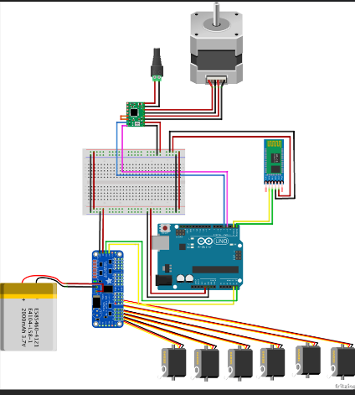

**Fig 1: Circuit diagram of Robotic Arm**

The capacity to smoothly combine human control with machine accuracy has emerged as an intriguing frontier in the rapidly developing field of robotics. The goal of this project is to create a six-axis robotic arm that can be fully controlled with natural hand gestures, enabling users to handle the robotic arm as an extension of their own movements and pushing the boundaries of human-robot interaction.

A robotic glove with a variety of sensors that can recognize and convert the user's hand and finger movements into exact orders for the robotic arm is at the center of this cutting-edge technology. The user may effortlessly control the opening, shutting, and rotation of the robotic arm by imitating natural actions like pinching or rotating their wrist. This results in a control experience that is both immersive and intuitive.

This initiative eliminates the boundaries between the digital and physical domains, marking a significant leap in the field of human-robot interaction. Users can now manage a sophisticated robotic system with the same ease and fluidity as they would manipulate their own limbs by taking use of the flexibility and adaptability of the human hand. This smooth human-machine interaction has the potential to transform a number of sectors, including manufacturing, assembly, healthcare, and assistive technology.

With the creation of this six-axis robotic arm that is operated by a robotic glove, our goal is to expand the realm of robotics' potential. In order to facilitate a more natural and interesting user experience and pave the way for a time when people and machines coexist peacefully, we want to give users the ability to control the robotic arm with their own natural gestures.

This system's ability to seamlessly combine human control and machine accuracy has the potential to revolutionize a number of sectors and applications, including:  
 By enabling more effective and deft manipulation of robotic arms, the robotic glove's user-friendly control interface may boost output, lower mistakes, and increase worker safety in industrial settings. By improving the dexterity and control of people with physical limitations, the robotic arm and glove system can help with physical rehabilitation exercises and offer haptic feedback during remote medical operations. The robotic arm and glove system may be used as a platform for more research as well as an instructional tool to teach computer science, robotics, and engineering principles.

The six-axis robotic arm, in conjunction with the precise control offered by the robotic glove, enables the execution of complex movements and tasks with a high degree of accuracy. The democratization of these technologies and the use of off-the-shelf components, like the Arduino microcontroller, can make the robotic arm and glove system more accessible to a wider range of users and applications. This makes the robotic arm and glove system more natural and engaging for the user.

To enable extended and pleasant usage, particularly in industrial or medical contexts, the robotic glove's design must take into account concerns of comfort, flexibility, and seamless integration with the user's hand. An important issue still lies in creating sophisticated control algorithms and machine learning methods that reliably transform the user's hand gestures into precise commands for the robotic arm. For these technologies to be widely used and accepted, it is imperative that the integrated system be safe and reliable, especially in shared human-robot workspaces. Flex sensors and accelerometers are the main sensing modalities used in the present system; adding other modalities like force sensing and haptic feedback might improve both the system's general functioning and user experience.

**LITERATURE REVIEW**

The development of robotic arms and their integration with wearable robotic gloves have been the subject of extensive research in the field of robotics and automation. This literature review provides a comprehensive overview of the key design considerations, technological advancements, and applications of these integrated systems, highlighting their potential to revolutionize various industries through enhanced human-robot collaboration.

* 1. Robotic Arm Design and Control

At the core of the robotic arm project is the design and control of the robotic manipulator itself. The literature emphasizes that the mechanical structure and kinematic configuration of the robotic arm are crucial factors in determining its capabilities and performance. Researchers have explored various robotic arm architectures, including serial, parallel, and hybrid designs, each with its own advantages and trade-offs.

Serial robotic arms, which consist of a sequence of links connected by revolute or prismatic joints, are widely used in industrial applications due to their flexibility and dexterity. However, these arms can suffer from issues such as limited payload capacity and susceptibility to vibrations. In contrast, parallel robotic arms, which have multiple kinematic chains connecting the base to the end-effector, offer improved rigidity, accuracy, and speed, making them suitable for high-precision tasks. Hybrid designs that combine serial and parallel architectures have also been investigated, aiming to leverage the strengths of both approaches.

The literature also highlights the importance of the robotic arm's degrees of freedom (DOF) in determining its range of motion and task-solving capabilities. Higher DOF arms can perform more complex movements and manipulations, but this comes at the cost of increased control complexity and potential instability. Researchers have explored various control strategies, such as PID control, adaptive control, and machine learning-based approaches, to address these challenges and ensure precise and stable operation of the robotic arm.

The role of the Arduino microcontroller in industrial robotic systems is also emphasized in the literature. The Arduino is often used to handle the low-level functions of the robotic arm, such as operating motors, servos, and other mechanical parts, as well as collecting data from sensors. This integration of the Arduino with the robotic arm's control system allows for a modular and flexible approach to system development and implementation.

2.2 Robotic Glove Design and Integration

Alongside the robotic arm, the literature review highlights the growing interest in the development and integration of robotic gloves for enhanced human-robot interaction. These wearable devices are designed to capture the user's hand movements and gestures, which can then be translated into control commands for the robotic arm.

The key components of the robotic glove typically include flex sensors, accelerometers, and an Arduino microcontroller. The flex sensors are used to detect the bending and flexing of the user's fingers, while the accelerometers track the overall hand movements and gestures. The Arduino Nano microcontroller processes the sensor data and transmits the control signals to the robotic arm via a wireless Bluetooth connection.

The literature emphasizes the importance of the glove's design and ergonomics, as it needs to be comfortable, durable, and seamlessly integrated with the user's hand. Researchers have explored various materials and fabrication techniques, such as 3D printing and soft robotics, to create gloves that are both functional and user-friendly.

One of the key challenges highlighted in the literature is the need to accurately translate the user's hand movements and gestures into precise control commands for the robotic arm. This requires advanced algorithms and machine learning techniques to interpret the sensor data and map it to the appropriate robotic arm movements. Researchers have explored various approaches, including neural networks, fuzzy logic, and gesture recognition algorithms, to address this challenge.

The integration of the robotic glove with the robotic arm is also a critical aspect discussed in the literature. The seamless communication and synchronization between the two systems are essential for achieving intuitive and responsive control. The literature emphasizes the importance of the wireless Bluetooth connection, as it allows for untethered operation and greater flexibility in the user's movements.

2.3 Applications and Trends

The literature review also explores the various applications and emerging trends in the field of robotic arms and gloves. One of the key areas highlighted is the use of these integrated systems in industrial manufacturing and assembly tasks. The robotic arm's precision, speed, and repeatability, combined with the intuitive control provided by the robotic glove, can enhance productivity, reduce errors, and improve worker safety in industrial environments.

Another area of interest is the use of robotic arms and gloves in medical and rehabilitation applications. The literature suggests that these systems can be used for tasks such as assisting with physical therapy exercises, providing haptic feedback for remote medical procedures, and aiding individuals with physical disabilities. The customizable and adaptable nature of these systems allows for personalized solutions tailored to the specific needs of each patient.

The literature also highlights the potential of robotic arms and gloves in the field of education and research. These systems can be used as educational tools to teach robotics, engineering, and computer science concepts, as well as serve as platforms for further research and development in areas such as human-robot interaction, dexterous manipulation, and sensor integration.

Emerging trends in the field include the integration of advanced technologies, such as artificial intelligence and augmented reality, to enhance the capabilities and user experience of robotic arm and glove systems. Additionally, the literature suggests that the increasing availability of low-cost, off-the-shelf components, such as the Arduino microcontroller, is driving the democratization of these technologies, making them more accessible to a wider range of users and applications.

2.4 Challenges and Future Directions

As the literature review highlights the significant progress made in the development of robotic arms and gloves, it also identifies several challenges and areas for future research and development. One of the key challenges is the need for improved ergonomics and user comfort in the design of the robotic glove. The glove must be lightweight, flexible, and seamlessly integrated with the user's hand to ensure prolonged and comfortable use, especially in industrial or medical settings.

Another challenge is the development of more advanced control algorithms and machine learning techniques to enhance the accuracy and responsiveness of the robotic arm's movements in response to the user's hand gestures. Improving the interpretation of complex hand movements and the translation into precise robotic arm control commands remains an active area of research.

The literature also emphasizes the importance of ensuring the safety and reliability of these integrated systems, particularly in shared human-robot workspaces. Addressing issues such as collision avoidance, force control, and human-robot collaboration protocols is crucial for the widespread adoption and acceptance of these technologies.

Finally, the literature suggests that future research should explore the potential of incorporating additional sensing modalities, such as haptic feedback and force sensing, to further enhance the user's experience and the overall functionality of the robotic arm and glove system. This could lead to more immersive and intuitive control interfaces, as well as the ability to perform more complex and dexterous manipulations.

**WORKING**

* 1. 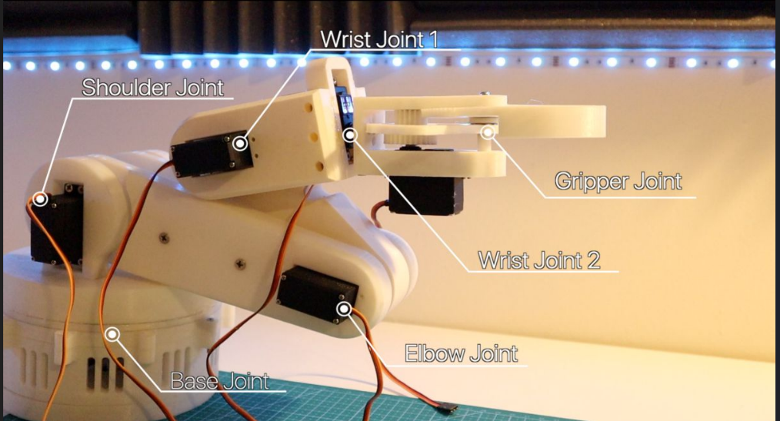**Working principle**

**Fig 2: Robotic Arm**

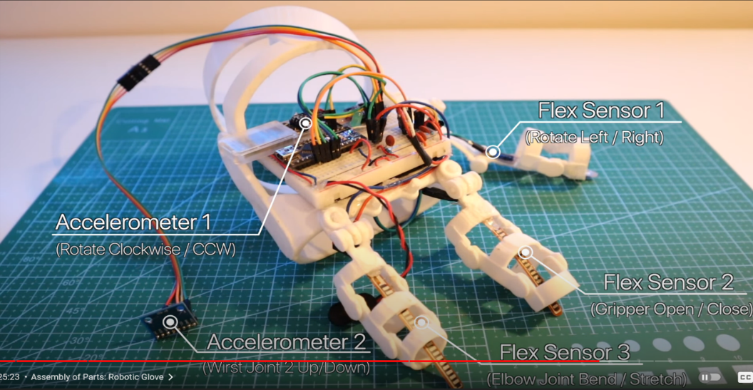

**Fig 3: Robotic glove**

* The robotic arm project utilizes Bluetooth connectivity for sensor-based gesture detection and servo motor control.
* The project consists of two main components: the robotic glove equipped with flex sensors and an accelerometer (MPU6050), and the robotic arm driven by servo motors.
* The robotic glove serves as the interface between the user's hand motions and the robotic arm, with flex sensors tracking finger joint bend and the accelerometer recording hand and wrist motions.
* The Arduino microcontroller in the robotic glove analyses sensor data upon gesture detection and translates it into values corresponding to specified motions.
* These mapped values are wirelessly transmitted via Bluetooth to the Arduino microcontroller on the robotic arm, which interprets and converts them into commands for the servo motors.
* Each servo motor in the robotic arm is assigned a specific function corresponding to a joint or motion, allowing the arm to mimic the user's movements.
* The servo driver adjusts the position of the servo motors based on instructions from the microcontroller, facilitating smooth and intuitive control of the robotic arm.
* The modular design of the system allows for scalability and expansion, with the ability to add more servo motors for additional functionality and more sensors for capturing subtle hand movements.
* Overall, this project showcases the integration of sensor technology, wireless communication, and robotic control concepts to create a flexible and user-friendly robotic system.

4.2. Components

Components of Robotic Arm:

1. Servo Motor
2. Servo Driver
3. Stepper Motor
4. Stepper Driver
5. Arduino UNO
6. Bluetooth
7. Battery
8. SMPS
9. Breadboard
10. Jumper wires

Components of Robotic Glove

1. Flex Sensors
2. Accelerometer
3. Bluetooth
4. Arduino NANO
5. Breadboard
6. Jumper Wires
7. Resistors
8. Battery
9. SMPS

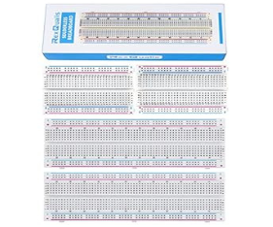

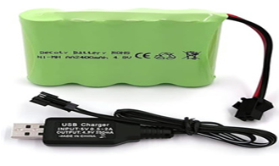

**Fig 4: Breadboard Fig 5: Battery**

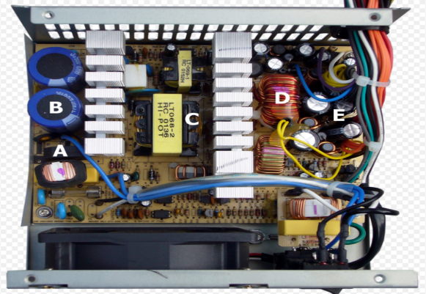

**Fig 6: Jumper Wires Fig 7: SMPS**

4.2.1. Servo Motor

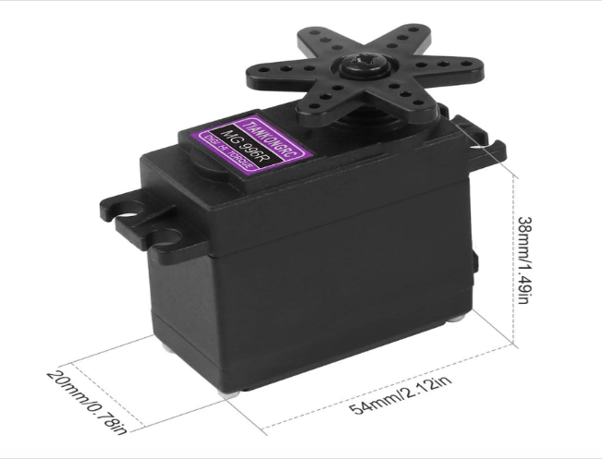

**Fig 8: Servo motor**

A servo motor in a robotic arm is a precise and powerful component that converts rotational motion into linear motion. It consists of an electronic assembly with an AC or DC electric motor, a controller board, and a potentiometer. Servo motors are crucial in robotics for their ability to provide accurate control over angular position, velocity, and acceleration, making them ideal for tasks requiring precise movements. They are commonly used in various applications such as industrial automation, robotics, conveyor systems, antenna positioning, simulation, renewable energy, printing, food and beverage industries, defense, and oil exploration due to their efficiency, precision, and reliability.

Working Principle:

A servo motor is a closed-loop system that uses feedback to control its speed, position, and torque. It uses Pulse Width Modulation (PWM) to vary the pulse width, generating an error signal to reduce errors and achieve desired positions, making them ideal for precise positioning.

4.2.2. Servo Driver

The servo motor driver is a critical component that enables precise control of the servo motors in a robotic arm. The driver circuit uses Pulse Width Modulation (PWM) to specify the desired angular position of the servo by varying the pulse width within a standard 20ms frame. Microcontrollers like Arduino can generate the appropriate PWM signals to control multiple servo motors simultaneously. The servo driver circuitry is responsible for converting the digital control signals from the microcontroller into the analog power required to accurately position and move the servo motors, which is essential for the smooth and precise operation of the robotic arm.

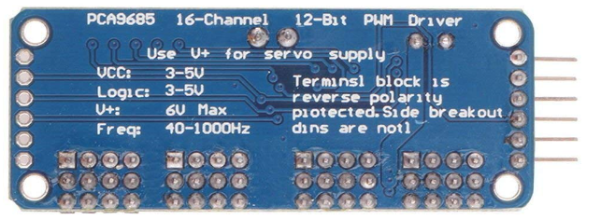

**Fig 9 : Servo driver**

4.2.3. Stepper Motor:

**Fig 10 : Stepper motor**

Stepper motors are a common choice for actuating the joints and movements of robotic arms. Unlike servo motors, stepper motors do not require feedback sensors to precisely control their position. Instead, they rely on an open-loop control system that precisely tracks the number of steps the motor has taken to determine its angular position.

The key functionality of stepper motors in a robotic arm includes: Stepper motors can be commanded to move a precise number of steps, allowing for very accurate positioning of the robotic arm's joints and links. This is crucial for tasks requiring repeatable, high-precision movements. Stepper motors are capable of providing high torque, which is important for supporting the weight of the robotic arm and its payload, especially at the base joints. The motion of stepper motors can be easily programmed and controlled using microcontrollers like Arduino. This allows for flexible, user-defined control of the robotic arm's movements. Stepper motors have a relatively simple control mechanism compared to servo motors, which require more complex feedback control systems. This can simplify the overall design and control of the robotic arm. However, stepper motors do have some limitations compared to servomotors, such as lower torque density, potential for step loss under heavy loads, and the need for more complex gearing or linkages to achieve the desired range of motion and speed.Overall, the precise position control, high torque, and programmability of stepper motors make them a popular choice for actuating the joints and movements of robotic arms in a wide range of applications

4.2.4. Stepper Driver:

The stepper motor driver is a crucial component in a robotic arm that enables precise control and actuation of the stepper motors. The driver circuit generates the appropriate sequence of step signals to energize the coils of the stepper motors, determining their direction and speed of rotation. It also amplifies the low-level control signals from the microcontroller to provide the necessary current to drive the stepper motor windings. Additionally, the driver often supports features like microstepping for smoother and more precise control, as well as protection circuitry to guard against voltage spikes and back-EMF. By handling the complex electrical requirements of the stepper motors, the driver circuit simplifies the interface between the microcontroller and the motors, allowing the robotic arm to precisely control the position, speed, and torque of its joints and links.

**Fig 11:Stepper driver**

4.2.5. Arduino:

The Arduino microcontroller plays a crucial role in the functionality of the robotic arm. It is responsible for the precise control and coordination of the servo motors that actuate the various joints and movements of the robotic arm. The Arduino generates the appropriate Pulse Width Modulation (PWM) signals to control the position, speed, and torque of the servo motors. It also interfaces with additional components like joysticks or touch interfaces to allow the user to command the desired movements of the robotic arm.

The Arduino's programmability enables complex motion sequences to be executed, making it a versatile and essential component in the design and operation of the robotic arm. By handling the low-level control of the motors and sensors, the Arduino simplifies the overall system and allows the robotic arm to perform a wide range of tasks with a high degree of precision and repeatability.

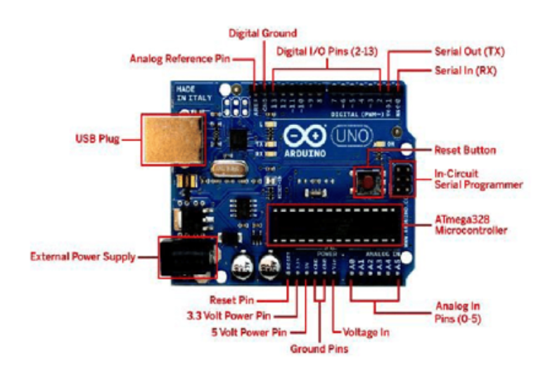

**Fig 12: Arduino Uno**

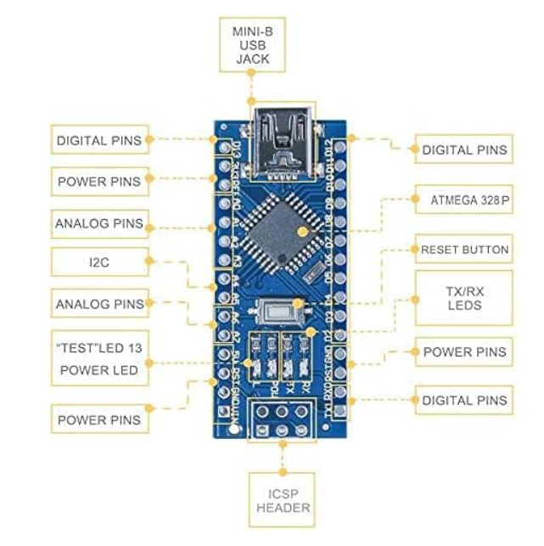

**Fig 13: Arduino Nano**

4.2.6. Bluetooth:

Bluetooth technology is integral to the functionality of both the robotic arm and robotic glove systems. In the context of the robotic glove, Bluetooth HC-05 modules facilitate wireless communication between the glove and the robotic arm, enabling users to control the arm through intuitive hand gestures detected by sensors in the glove. This wireless connection allows for precise and accurate control of the robotic arm based on the user's movements. Additionally, the wireless glove systems, such as the Wireless Glove and the Wireless Somatosensory Mechanical Glove, are designed to be compatible with the Arduino development environment, incorporating built-in Bluetooth modules that enable seamless communication with other devices. Overall, Bluetooth technology enhances the user experience by providing a wireless and efficient means of controlling robotic arms through natural hand movements and gestures.

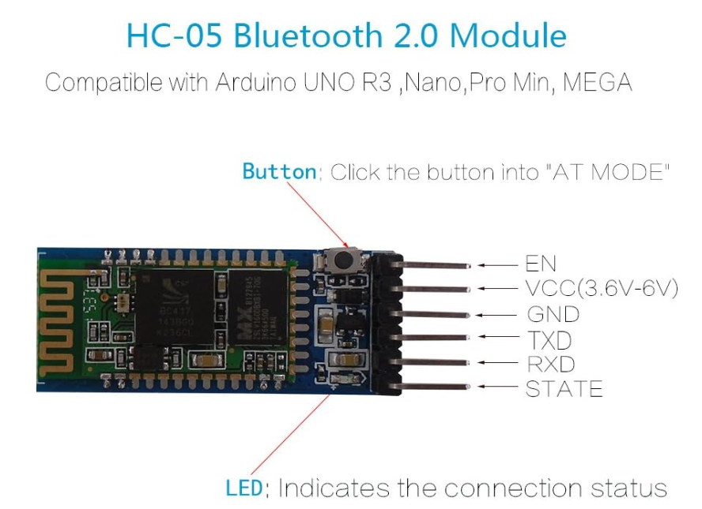

**Fig 14: Bluetooth**

4.2.7. Accelerometer:

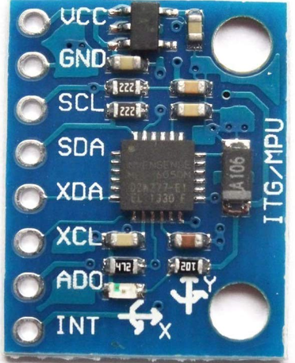

**Fig 15: Accelerometer**

Accelerometers play a significant role in both the robotic arm and robotic glove systems. In the context of the robotic arm, accelerometers are utilized to collect data from human gestures, enabling precise and intuitive control of the arm's movements. These sensors detect specific gestures and transmit the data to the Arduino microcontroller, allowing the robotic arm to respond smoothly and accurately to the user's commands. On the other hand, in the robotic glove system, accelerometers are integrated to detect hand movements and gestures made by the user. This data is then sent to the Arduino nano, facilitating the control of the robotic arm based on the user's gestures. The accelerometers in the robotic glove contribute to the system's ability to interpret hand movements effectively, translating them into corresponding actions by the robotic arm. Overall accelerometers play a crucial role in both the robotic arm and robotic glove systems by enabling the detection and transmission of human gestures to control the movements of the robotic arm accurately and efficiently.

4.2.8. Flex Sensor:

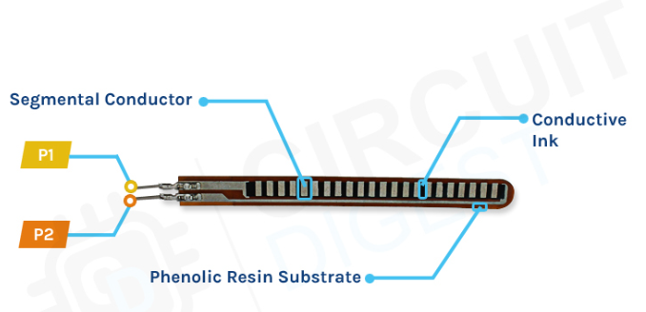

**Fig 16: Flex Sensor**

The flex sensors play a crucial role in the functionality of both the robotic glove and the robotic arm. In the robotic glove, three flex sensors are used to detect the movement and gestures of the user's fingers and hand. Specifically, Flex Sensor 1 is used to detect rotation left/right, Flex Sensor 2 is used for gripper open/close, and Flex Sensor 3 is used for elbow joint bend/stretch. The flex sensor data is then transmitted to the Arduino or Raspberry Pi microcontroller, which generates the appropriate control signals to actuate the servomotors in the robotic arm, enabling precise and smooth movements that mimic the user's natural hand and finger motions. This allows for an intuitive and seamless control interface, where the user can manipulate the robotic arm through their own hand gestures, enhancing the precision and dexterity of the system.

**4.3 Robotic Arm Mapping:**

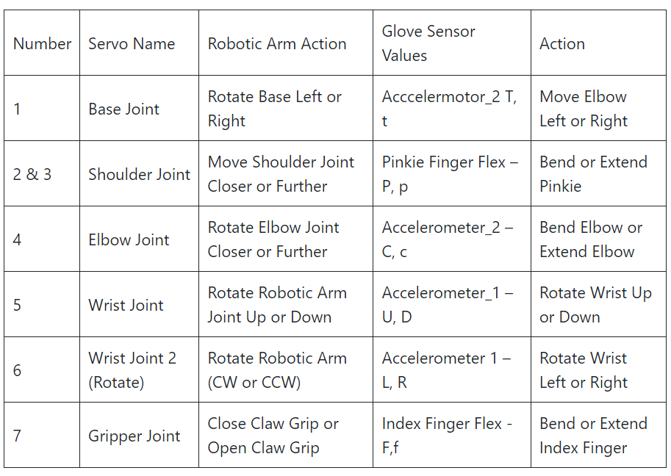**Table 1: Arm mapping**

**4.4 Assembly of Parts:**

4.4.1. Robotic Arm Assembly

* Part 1: [Gripper Parts](https://www.thingiverse.com/thing:1748596)
* Part 2: [Base and Turntable](https://www.thingiverse.com/thing:1750025)
* Part 3: [Robotic Core Arm](https://www.thingiverse.com/thing:1838120)

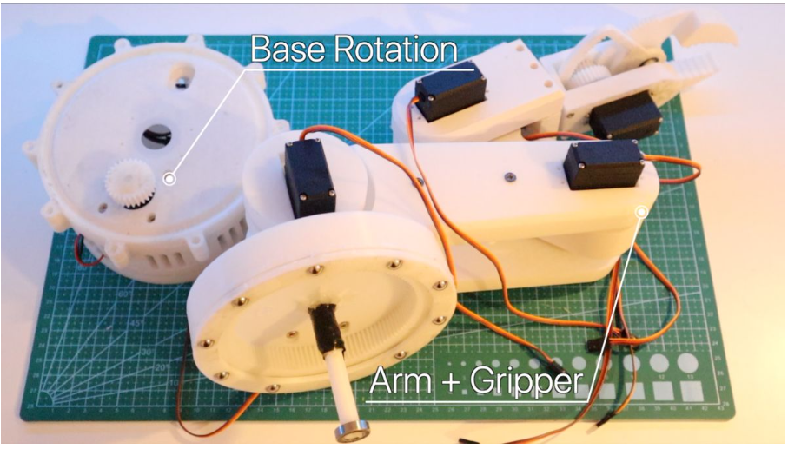

**Fig 17: Block diagram of Robotic arm**

The robotic arm assembly involves carefully aligning and securing the various components, including the servo motors, to create a functional robotic arm. The assembly process typically takes around two hours to complete without errors.

The key steps in the assembly include:

* Preparing the servos: Ensuring all the servos are positioned at 90 degrees using a simple Arduino program.
* Attaching the base: Mounting the base of the robotic arm, which is typically made of wood or a c-clamp, to provide a stable foundation.
* Assembling the core arm: Connecting the shoulder, elbow, and wrist joints of the robotic arm using the appropriate screws (M3 8mm, M3 10mm, M4 10mm) to create the movable segments.
* Attaching the gripper: Securing the gripper or end-effector to the wrist of the robotic arm, allowing it to rotate and position objects as needed.
* Wiring and integration: Connecting the servo motors to the Arduino or microcontroller using jumper wires to enable precise control over the arm's movements.

This emphasizes the importance of understanding the proper placement and usage of the various screws to ensure the functionality and stability of the assembled robotic arm. Additionally, protecting the work surface and maintaining a safe distance from the arm during assembly are recommended.

The below wiring diagram shows the final assembly of all electronic parts to create a Robotic arm, including the Bluetooth module. We’ll cover the paring process below.

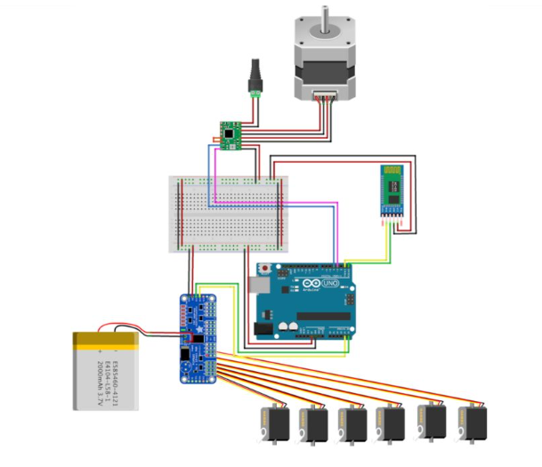

**Fig 18: Robotic Arm Circuit Diagram**

4.4.2. Robotic Glove Assembly

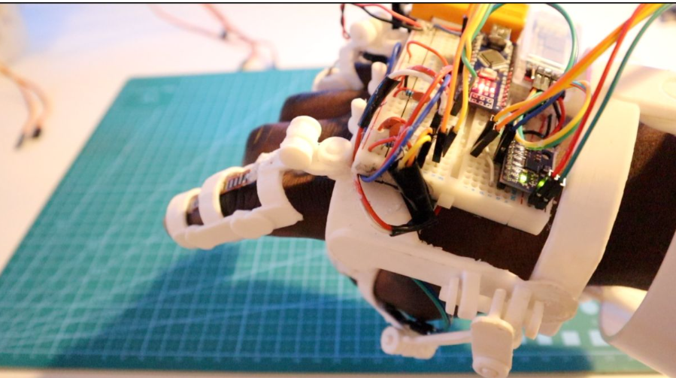

**Fig 19: Robotic Glove**

The robotic glove is a key component that allows for intuitive control of the robotic arm through natural hand gestures. The assembly of the robotic glove involves the following steps:

1. Preparing the Flex Sensors:

The glove contains 3 flex sensors that are used to detect the movement and gestures of the user's fingers and hand.Small holes are drilled at the top of the flex sensors (avoiding the resistive material) to allow for sewing them onto the glove.

1. Attaching the Flex Sensors:

The glove is worn tightly, and lines are marked on the fingers to indicate the placement of the flex sensors.The flex sensor tips are sewn onto the areas just above the fingernails, and the sensors are looped around the finger joints to secure them.

The flex sensor PCB is then sewn tightly onto the wrist part of the glove.

1. Integrating the Accelerometers:

The glove also incorporates 2 accelerometers to detect hand movements and gestures made by the user.The accelerometers are integrated into the glove design to contribute to the system's ability to interpret the user's hand movements.

1. Connecting the Arduino Nano:

An Arduino Nano microcontroller is used in the glove to process the data from the flex sensors and accelerometers.

The Arduino Nano is connected to the various sensors and components within the glove.

1. Adding the Bluetooth Module:

A Bluetooth HC-05 module is integrated into the glove to enable wireless communication between the glove and the robotic arm.This wireless connection allows the user to control the robotic arm through the gestures and movements detected by the sensors in the glove.

The assembly process involves carefully sewing, wiring, and integrating these components to create a functional and intuitive robotic glove interface for controlling the robotic arm.

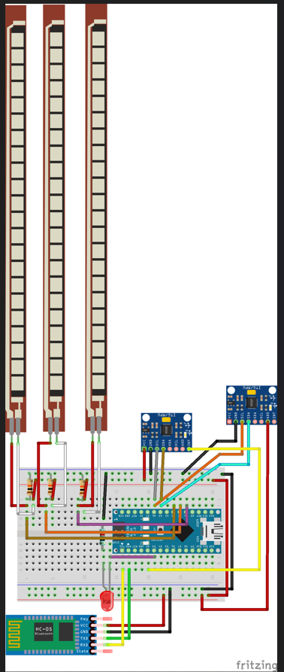

**Fig 20: Robotic glove circuit diagram**

4.4.3 Integrating the Robotic Arm with Robotic Glove

Connect the robotic glove to the robotic arm: Establish the wireless Bluetooth connection between the glove and the Arduino or microcontroller controlling the robotic arm.

Ensure proper wiring and power supply: Provide the necessary power supply and connect the various components to enable the seamless operation of the integrated system. The assembly process involves carefully aligning and securing the components, as well as programming the Arduino or microcontroller to enable the intuitive control of the robotic arm through the user's hand gestures detected by the robotic glove.

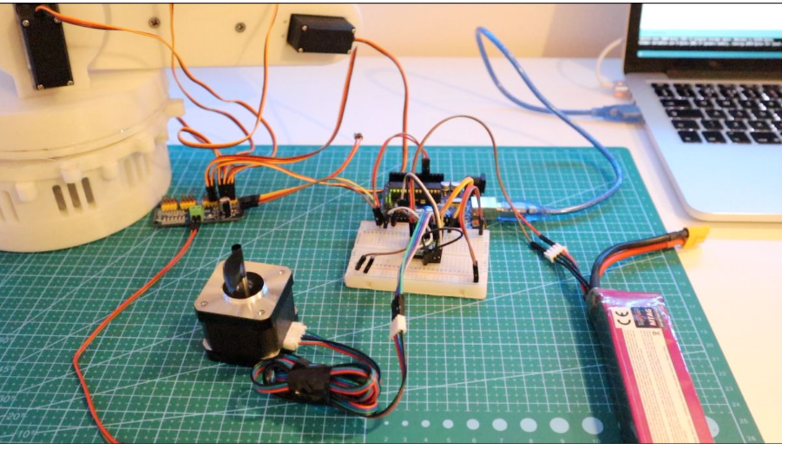

**Fig 21: Robot Arm – Full Assembly and Wiring**

**4.5 Configuring the Bluetooth (Master and Receiver):**

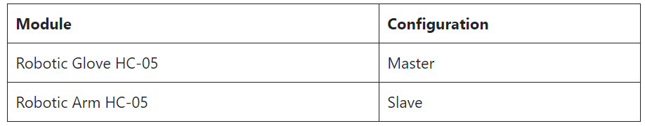The Arduino Robotic Arm communicates over Bluetooth using the HC-05 modules. Below highlight the critical information.

**Table 2:Bluetooth Module**

**ARDUINO CODE**

/*Robotic Arm*/

#include <Wire.h>

#include <Adafruit_PWMServoDriver.h>

Adafruit_PWMServoDriver srituhobby = Adafruit_PWMServoDriver();

#define servoMIN 150

#define servoMAX 400

const int dirPin = 3;

const int stepPin = 4;

const int stepsPerRevolution = 100;

int stepDelay = 5000;

void setup() {

srituhobby.begin();

srituhobby.setPWMFreq(60);

pinMode(stepPin, OUTPUT);

pinMode(dirPin, OUTPUT);

}

void loop() {

//clockwise

digitalWrite(dirPin, HIGH);

// Spin motor

for (int x = 0; x < stepsPerRevolution; x++) {

digitalWrite(stepPin, HIGH);

delayMicroseconds(stepDelay);

digitalWrite(stepPin, LOW);

delayMicroseconds(stepDelay);

}

delay(1000); // Wait a second

srituhobby.setPWM(0, 0, servoMIN);

// delay(2000);

srituhobby.setPWM(1, 0, servoMAX);

delay(2000);

srituhobby.setPWM(2, 0, servoMIN);

delay(2000);

srituhobby.setPWM(3, 0, servoMAX);

delay(2000);

srituhobby.setPWM(4, 0, servoMIN);

delay(2000);

srituhobby.setPWM(5, 0, servoMAX);

delay(3000);

srituhobby.setPWM(5, 0, servoMIN);

delay(2000);

srituhobby.setPWM(4, 0, servoMAX);

delay(2000);

srituhobby.setPWM(3, 0, servoMIN);

delay(2000);

srituhobby.setPWM(2, 0, servoMAX);

delay(2000);

srituhobby.setPWM(1, 0, servoMIN);

// delay(2000);

srituhobby.setPWM(0, 0, servoMAX);

delay(2000);

// Spin motor

digitalWrite(dirPin, LOW);

for (int x = 0; x < stepsPerRevolution; x++) {

digitalWrite(stepPin, HIGH);

delayMicroseconds(stepDelay);

digitalWrite(stepPin, LOW);

delayMicroseconds(stepDelay);

}

delay(5000); // Wait a second

} **CONCLUSION**

A significant step toward the creation of perceptive and flexible robotic systems has been taken with the development of the robotic arm project. Through the project's integration of Bluetooth connectivity, servo motor control, and sensor-based gesture recognition, users may easily control the robotic arm's movements with natural hand gestures. This novel method not only makes robotic technology more accessible and user-friendly, but it also creates a plethora of opportunities for applications across a range of industries, from industrial automation to assistive technologies. Further advancements in this sector of research and development might lead to a new age of interactive human-machine cooperation by expanding the capabilities and diversity of robotic systems.

6.1. Future Scope

The robotic arm project has a wide and bright future ahead of it, with chances for more development and innovation in a number of important fields. First off, improvements in sensor technology, such as the creation of more accurate and sensitive sensors, will improve the robotic arm's utility and adaptability by improving its capacity to recognize and react to minute hand gestures and motions. Further enhancing its functionality and efficiency is the robotic arm's ability to automatically learn and adjust its behaviour in response to human preferences and environmental cues through the integration of artificial intelligence and machine learning algorithms.

Overall, the future of the robotic arm project holds immense potential for continued innovation and growth, with opportunities to enhance its capabilities, expand its applications, and further

revolutionize human-machine interaction in diverse fields.

**REFERENCES**

1. Priyambada Mishra, Riki Patel, Trushit Upadhyaya, Arpan Desai “Review of Development Of Robotic Arm Using Arduino UNO”, International Journal on Recent Researches in Science, Engineering and Technology, ISSN: 2348-3105 Volume 5, Issue 5, May 2017.
2. Puran Singh, Anil Kumar, Mahesh Vashishth “Design of Robotic Arm with Gripper and End effector for spot welding”, Universal Journal of Mechanical Engineering 1(3); 92-97, 2013, DOI: 10.13189/ujme,2013.010303.
3. Anughna N, Ranjitha V, Tanuja G “Design and Implementation of Wireless Robotic Arm Model using Flex and Gyro Sensor”, International Journal of Recent Technology and Engineering (IJRTE) ISSN: 2277-3878, Volume-8 Issue-5, January 2020.
4. Shamsheer Verma “Hand Gestures Remote Controlled Robotic Arm”, Advance in Electronic and Electric Engineering. ISSN 2231-1297, Volume 3, Number 5 (2013), pp. 601-606.
5. Gurudu Rishank Reddy and Venkata Krishna Prashanth Eranki “Design and Structural Analysis of a Robotic Arm” Blekinge Institute of Technology, Karlskrona, Sweden, 2016, ISRN: BTH-AMT-EX--2016/D06—SE.